Pre-processing Document
UK Crime Analysis for Real Estate Decision making

Data Sources
All data was obtained from UK police open data at https://data.police.uk/data/. Once the four police forces and timeframe were decided, monthly crime files were downloaded as CSVs. Four police forces over 24 months totalling 96 CSV files downloaded into data_raw folder.

Data LOADING
The data loading and cleaning steps took place in a Jupyter Notebook using pandas. First the pandas library was imported and a sample file was loaded to understand the structure of the data. Once this had been completed the full dataset containing all 96 CSVs could be loaded.
Each CSV was then loaded into a data frame and were stored in a list so then can later be combined into a single dataset. After confirming all files loaded correctly, the structure of each file was compared with the first – ensuring the same structure across all files. After confirming that all datasets share the same column structure, they were combined into a single data frame. This was done using vertical concatenation, where each dataset was stacked on top of the others. The resulting dataset contained all crime records across the selected police forces and time period.

Data Cleaning
Firstly, missing values were checked in the data so they could be handled accordingly. The ‘Context’ column contained only null values and was therefore dropped. There were also some nulls in ‘Crime ID’ and ‘Last outcome category’ which seemed to perfectly align. This is due to not all crimes having a public identifier and therefore a recorded outcome, so these records were retained to avoid removing valid crime events.
A very small number of rows were missing geographic data in ‘Longitude’ and ‘Latitude’, most of which were in the Dyfed-Powys region, this is likely due to the scarce population, and the data was removed from public view for privacy regions. Again, these rows were kept to avoid removing valid crimes however, they will be excluded from the crime map.
The ‘Month’ column was used to create the ‘Date’ column in the datetime format. This allows for time-based analysis as the original ‘Month’ column is text not a date format. Crime category values were also checked, ensuring the category names were consistent across police forces. The dataset was then sorted by date and then police force, resulting in a chronological dataset while grouping the police forces consistently within each time period. The index was also reassigned so the numbers ran sequentially.
After checking all months and police forces are present in the final dataset, it can be exported as a CSV to the folder ‘data_clean’ for analysis.

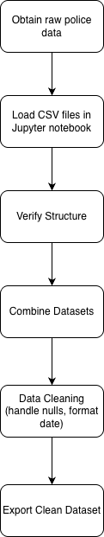
Flowchart

